**Sprint 3 Plan**

**Project Name:** VTC

**Team Name:** VTC Team

**Sprint Completion:** 3/4/2018

**Goal:**

This sprint is allocated to connecting all different components together as well as on improve existing components of application. We will complete user account/friend verification and system. We will also implement uploading media functionality as well as completion of unfinished components from the last sprint.

**Task Listing:**

1. Merging tasks (8)
   1. As developers, once everyone’s parts are finished, we want to the connect Firebase to the user pages; thus, allowing the user pages to update automatically.
      1. Task 1 (2) (everyone): Set up a meeting time with developers
      2. Task 2 (3) (Michael and Ruchi): Connect the signup and email verification
      3. Task 3 (3) (Michael and Austin): Connect media uploading functionality on friend page
      4. Task 4 (3) (Michael and Lizette): (3) Connect firebase and login page
      5. Task 5 (3) (Ruchi and Gamiel): Connect facebook logins with login page
      6. Task 6 (3) (Gamiel and Lizette): Connect facebook friends with friends page
2. Allow users to choose photos to upload (5)
   1. As a user, I want to be able to choose photos/videos from my camera storage to upload.
      1. Task 1 (3): Select multiple photos to upload
      2. Task 2 (2): Enable video recording
      3. Task 3 (3): Select video to upload
      4. Task 4 (5): Send URIs to firebase and upload media
3. Implement the friend system (5)
   1. As a developer, I want to ensure there is a space within the app where users can find their friends and create groups.
      1. Task 1 (2) create friend page
      2. Task 3 (3) Create page for friend groups
4. Implement the time system (5)
   1. As a user, I want to receive my time capsule at the time that I set.
      1. Task 1 (5) (Matt) Implement a time system, set by user, to deliver data back to user or other users
5. Create notification message pop-up (5)
   1. As a user, I want to have a notification sent to me when someone sends me a message.
      1. Task 1 (3) (Matt) Implement notification “pop-up” once user-defined time is reached.

**Team Roles:**

1. Lizette: Product Owner
2. Michael: Developer
3. Ruchi: Scrum master
4. Gamiel: Developer
5. Matthew: Developer
6. Austin: Developer

**Initial Task Assignment:**

1. Lizette: (5) Menu Functionalities, (2) create friend page
2. Michael: (3) Connect the signup and email verification, (3) Connect media uploading functionality on friend page, (3) Connect firebase and login page
3. Ruchi: (3) Create page for friend groups, (3) Connect facebook logins with login page
4. Gamiel: (3) Connect facebook logins with login page (3) Connect facebook friends with friends page
5. Matthew: (5) Time system, notification pop-up
6. Austin: Select multiple photos to upload (3), Enable video recording (2), Select video to upload (3), Send URIs to firebase and upload media (5)
7. Also look at tasks that were assigned in “Merging tasks”

**Initial Burn Up Chart:**

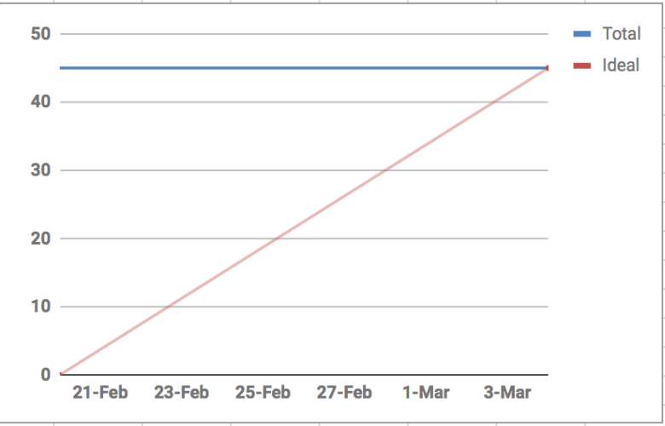**total = 46 points**

**Scrum Board:**

https://trello.com/b/VjEM6xgG/sprint-3

**Scrum Times:**

Sundays ~9PM,

Tuesdays ~9:30PM,

Thursdays 2-3 (TA 2:30)